**CCNA OSPF LAB PRACTICE**

1. Network Diagram

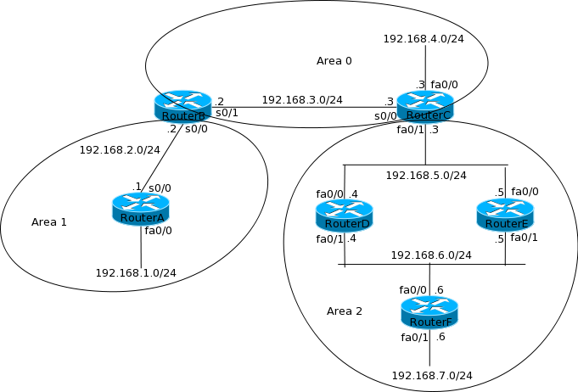

1. Packet Tracer Set Up

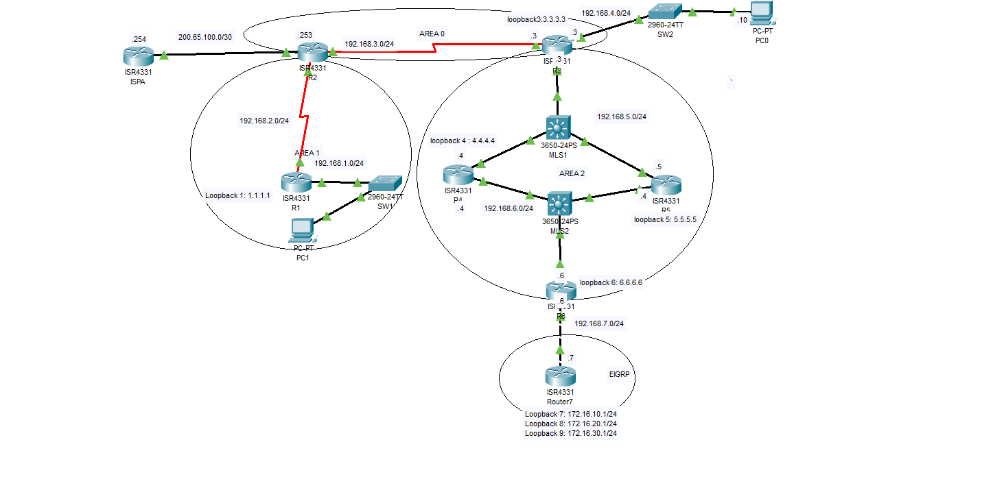

Port IP Address

Configure ports as below

|  |  |  |
| --- | --- | --- |
| Device | Port | Ip address |
| R1 | G0/0/0 | 192.168.1.1/24 |
| R1 | S0/2/0 | 192.168.2.1/24 |
| R1 | Loopback1 | 1.1.1.1/32 |
| R2 | G0/0/0/0 | 200.65.100.253/30 |
| R2 | S0/2/0 | 192.168.2.2/24 |
| R2 | S0/2/1 | 192.168.3.2/24 |
| R3 | G0/0/0 | 192.168.5.3/24 |
| R3 | G0/0/1 | 192.168.4.3/24 |
| R3 | S0/1/0 | 192.168.3.3/24 |
| R3 | Loopback 3 | 3.3.3.3/32 |
| R4 | G0/0/0 | 192.168.5.4/24 |
| R4 | G0/0/1 | 192.168.6.4/24 |
| R4 | Loopback4 | 4.4.4.4/32 |
| R5 | G0/0/0 | 192.168.5.5/24 |
| R5 | G0/0/1 | 192.168.6.5/24 |
| R5 | Loopback5 | 5.5.5.5/32 |
| R6 | G0/0/0 | 192.168.6.5/24 |
| R6 | G0/0/1 | 192.168.7.5/24 |
| R6 | Loopback6 | 6.6.6.6/32 |
| R7 | G0/0/0 | 192.168.7.7/24 |
| R7 | Loopback7 | 172.16.10.1/32 |
| R7 | Loopback8 | 172.16.20.1/32 |
| R7 | Loopback9 | 172.16.30.1/32 |
| ISPA | G0/0/0 | 200.65.100.254/30 |
| ISPA | Loopback100 | 8.8.8.8/32 |
| PC0 | FastEthernet | 192.168.4.10/24 |
| PC1 | FastEthernet | 192.168.1.10/24 |

**R1**

R1>

R1>

R1>en

R1#conf t

Enter configuration commands, one per line. End with CNTL/Z.

Interface G0/0/0

R1(config)#int g0/0/0

R1(config-if)#no shutdown

R1(config-if)#ip address 192.168.1.1 255.255.255.0

Loopback1

R1(config-if)#int lo1

R1(config-if)#ip address 1.1.1.1 255.255.255.255

R1(config-if)#no shutdown

Serial0/2/0 Interface

R1(config-if)#clock rate 9600

R1(config-if)#no shutdown

R1(config-if)#ip address 192.168.2.1 255.255.255.0

OSPF on R1

R1(config)#router ospf 10

R1(config-router)#router-id 10.10.10.1

R1(config-router)#network 1.1.1.1 0.0.0.0 area 1

R1(config-router)#network 192.168.2.1 0.0.0.0 area 1

R1(config-router)#network 192.168.1.0 0.0.0.255 area 1

R1(config-router)#passive-interface loopback 1

R1(config-router)#

R2

R2>

R2>en

R2#conf t

Enter configuration commands, one per line. End with CNTL/Z.

Serial 0/2/0 Interface

R2(config)#int s0/2/0

R2(config-if)#ip address 192.168.2.2 255.255.255.0

R2(config-if)#no shutdown

R2(config-if)#

%LINK-5-CHANGED: Interface Serial0/2/0, changed state to up

%LINEPROTO-5-UPDOWN: Line protocol on Interface Serial0/2/0, changed state to up

R2(config-if)#ip ospf 10 area 1

Serial 0/2/1 Interface

R2(config)#int s0/2/1

R2(config-if)#no sh

R2(config-if)#no shutdown

R2(config-if)#ip ad

R2(config-if)#ip address 192.168.3.2 255.255.255.0

Setting clock rate on s0/2/1

R2(config)#int s0/2/1

R2(config-if)#clock rate 9600

OSPF on R2

R2(config)#router ospf 10

R2(config-router)#router-id 10.10.10.2

R2(config-router)#network 192.168.2.2 0.0.0.0 area 1

R2(config-router)#network 192.168.3.2 0.0.0.0 area 0

R2(config-router)#

R3

R3#conf t

Enter configuration commands, one per line. End with CNTL/Z.

R3(config)#

R3(config)#

Serial 0/1/0 Interface

R3(config)#int s0/1/0

R3(config-if)#no shutdown

R3(config-if)#

R3(config-if)#ip address 192.168.3.3 255.255.255.0

R3(config-if)#ip ospf 10 area 0

R3(config-if)#

Interface G0/0/1

R3(config-if)#int g0/0/1

R3(config-if)#no shutdown

R3(config-if)#ip address 192.168.4.3 255.255.255.0

R3(config-if)#ip ospf 10 area 0

Creating loopback 3

R3#conf t

R3(config)#int lo3

R3(config-if)#

R3(config-if)#ip address 3.3.3.3 255.255.255.255

R3(config-if)#no shutdown

Router(config-if)#ip ospf 10 area 0

Interface G0/0/0

R3(config-if)#

R3(config-if)#int g0/0/0

R3(config-if)#ip address 192.168.5.3 255.255.255.0

R3(config-if)#no shutdown

Router(config-if)#ip ospf 10 area 2

R4

R4>

R4>en

R4#conf t

R4(config)#int g0/0/0

R4(config-if)#no sh

R4(config-if)#no shutdown

R4(config-if)#

R4(config-if)#

R4(config-if)#ip address 192.168.5.4 255.255.255.0

Configured OSPF at interface level

R4(config-if)#ip ospf 10 area 2

R4(config-if)#

R4(config-if)#exit

R4(config)#router ospf 10

R4(config-router)#router

R4(config-router)#router-id 10.10.10.4 (configured router-id)

R4(config-router)#

Loopback 4

R4(config-router)#int lo4

R4(config-if)#

R4(config-if)#no shutdown

R4(config-if)#ip address 4.4.4.4 255.255.255.255

Configured OSPF at interface level

R4(config-if)#ip ospf 10 area 2

R4(config-if)#exit

R4(config)#router ospf 10

R4(config-router)#passive-interface lo4

R4(config-router)#

Interface G0/0/1

R4(config-router)#int g0/0/1

R4(config-if)#no shutdown

R4(config-if)#ip address 192.168.6.4 255.255.255.0

Configured OSPF at interface level

R4(config-if)#ip ospf 10 area 2

Router(config-if)#

R5

R5>

R5>en

R5#conf

R5(config)#

Interface G0/0/0

R5(config)#int g0/0/0

R5(config-if)#no shutdown

R5(config-if)#ip address 192.168.5.5 255.255.255.0

R5(config-if)#exit

OSPF on R5

R5(config)#router ospf 10

R5(config-router)#router

R5(config-router)#router-id 10.10.10.5

R5(config-router)#network 192.168.5.5 0.0.0.0 area 2

Loopback 5

R5(config-router)#

R5(config-router)#int lo5

R5(config-if)#no shutdown

R5(config-if)#

R5(config-if)#ip address 5.5.5.5 255.255.255.255

R5(config-if)#exit

OSPF on R5 cntd

R5(config)#router ospf 10

R5(config-router)#network 5.5.5.5 0.0.0.0 area 2

R5(config-router)#passive-interface lo5

R6

Interface G0/0/1

R6(config-router)#

R6(config-router)#int g0/0/1

R6(config-if)#no shutdown

R6(config-if)#

R6(config-if)#ip address 192.168.6.5 255.255.255.0

R6(config-if)#exit

R6(config)#router ospf 10

R6(config-router)#network 192.168.6.5 0.0.0.0 area 2

R6(config-router)#

Interface G0/0/0

R6(config)#int g0/0/0

R6(config-if)#no shutdown

R6(config-if)#

R6(config-if)#ip address 192.168.6.6 255.255.255.0

R6(config-if)#

R6(config-if)#exit

OSPF on R6

R6(config)#router ospf 10

R6(config-router)#router-id 10.10.10.6

R6(config-router)#network 192.168.6.0 0.0.0.255 area 2

R6(config-router)#

R6(config-router)#

R6(config-router)#

Loopback 6

R6(config-router)#int lo6

R6(config-if)#

R6(config-if)#no shutdown

R6(config-if)#ip address 6.6.6.6 255.255.255.255

R6(config-if)#exit

OSPF on R6 cntd

R6(config)#router ospf 10

R6(config-router)#network 6.6.6.6 0.0.0.0 area 2

R6>en

R6#conf t

Interface G0/0/1

R6(config)#int g0/0/1

R6(config-if)#no shutdown

R6(config-if)#

R6(config-if)#ip address 192.168.7.6 255.255.255.0

Configured EIGRP 100 on R6

R6(config-if)#exit

Router(config)#router eigrp 100

Router(config-router)#no auto-summary

Router(config-router)#network 192.168.7.0 0.0.0.255

R7

R7>

R7>en

R7#conf t

R7(config)#line console 0

R7(config-line)#logging synchronous

R7(config-line)#

R7(config-line)#exit

Interface G0/0/0

R7(config)#int g0/0/0

R7(config-if)#no shutdown

R7(config-if)#ip address 192.168.7.7 255.255.255.0

Loopback 7

R7(config-if)#int lo7

R7(config-if)#

R7(config-if)#ip address 172.16.10.1 255.255.255.255

Loopback 8

R8(config-if)#int lo8

R8(config-if)#

R8(config-if)#ip address 172.16.20.1 255.255.255.255

Loopback 9

R8(config-if)#int lo9

R8(config-if)#

R8(config-if)#no sh

R8(config-if)#ip address 172.16.30.1 255.255.255.255

Redistributing the EIGRP Routes into OSPF on R6

R6#

R6#conf t

Enter configuration commands, one per line. End with CNTL/Z.

R6(config)#router ospf 10

R6(config-router)#redistribute eigrp 100 subnets

R2 to ISPA link

On R2

R2(config-router)#

R2(config-router)#int g0/0/0

R2(config-if)#no shutdown

R2(config-if)#

On ISPA

ISPA>en

ISPA#

ISPA#

ISPA#conf t.

ISPA(config)#int g0/0/0

ISPA(config-if)#no sh

ISPA(config-if)#ip address 200.65.100.254 255.255.255.252

ISPA(config-if)#

A loopback Interface outside the network

This is used to ping the outside network

ISPA(config-if)#int lo100

ISPA(config-if)#

ISPA(config-if)#no shutdown

ISPA(config-if)#ip address 8.8.8.8 255.255.255.255

Configure R2 to use its g0/0/0 interface as the default route to the internet

R2(config)#ip route 0.0.0.0 0.0.0.0 200.65.100.254

Configure R2 to advertise this default routes to all the routers

R2(config)#

R2(config)#router ospf 10

Router(config-router)#default-information originate

Configure route summarization on R7

R7(config)#int g0/0/0

R7(config-if)#ip summary-address eigrp 100 172.16.0.0 255.255.0.0

R7(config-if)#